# Loan Amortization Calculator

**LoanAmortizationCalculator.java**

package in.cdac.ques1;

import java.util.Scanner;

public class LoanAmortizationCalculator {

double principal;

double annualInterestRate;

int loanTerm;

int numberOfMonths;

double monthlyInterestRate;

double monthlyPayment;

double totalAmountPaid;

void acceptRecord(Scanner sc){

System.out.println("Enter Principal amount: ");

this.principal = sc.nextDouble();

System.out.println("Enter Annual Interest Rate: ");

this.annualInterestRate = sc.nextDouble();

System.out.println("Enter Loan Term in years: ");

this.loanTerm = sc.nextInt();

}

void printRecord(){

System.out.printf("Monthly Payment: %.2f Rs\n", this.monthlyPayment);

System.out.printf("Total Amount to be Paid: %.2f Rs", this.totalAmountPaid);

}

void calculateMonthlyPayment(){

numberOfMonths = loanTerm * 12;

monthlyInterestRate = annualInterestRate / 12 / 100;

monthlyPayment = principal * (monthlyInterestRate * Math.pow((1 + monthlyInterestRate),(numberOfMonths)))

/ (Math.pow((1 + monthlyInterestRate),(numberOfMonths)) - 1);

totalAmountPaid = monthlyPayment * numberOfMonths;

}

}

**Tester.java**

package in.cdac.ques1;

import java.util.Scanner;

public class Tester {

public static void main(String[] args) {

Scanner sc = new Scanner(System.in);

LoanAmortizationCalculator obj1 = new LoanAmortizationCalculator();

obj1.acceptRecord(sc);

obj1.calculateMonthlyPayment();

obj1.printRecord();

}

}

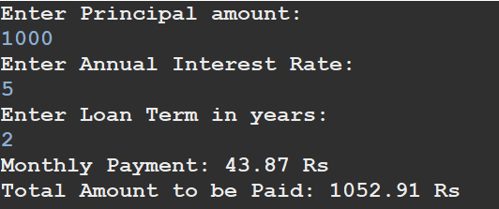

# Compound Interest Calculator for Investment

**CompoundInterestCalculator.java**

package in.cdac.ques2;

import java.util.Scanner;

public class CompoundInterestCalculator {

private double principal;

private double annualInterestRate;

private double numberOfCompounds;

private double years;

private double futureValue;

private double totalInterest;

public void acceptRecord(Scanner sc) {

System.out.print("Enter the initial investment amount: ");

this.principal = sc.nextInt();

System.out.print("Enter the annual interest rate: ");

this.annualInterestRate = sc.nextDouble();

System.out.print("Enter number of times the interest is compounded per year: ");

this.numberOfCompounds = sc.nextInt();

System.out.print("Enter investment duration in years: ");

this.years = sc.nextInt();

}

public void calculateFutureValue() {

futureValue = principal * Math.pow((1 + annualInterestRate / numberOfCompounds),(numberOfCompounds * years));

totalInterest = futureValue - principal;

}

public void printRecord() {

System.out.printf("Future Value: %.2f Rs\n",this.futureValue);

System.out.printf("Total Interest Earned: %.2f Rs",this.totalInterest);

}

}

**Tester.java**

package in.cdac.ques2;

import java.util.Scanner;

public class Tester {

public static void main(String[] args) {

Scanner sc = new Scanner(System.in);

CompoundInterestCalculator obj1 = new CompoundInterestCalculator();

obj1.acceptRecord(sc);

obj1.calculateFutureValue();

obj1.printRecord();

}

}

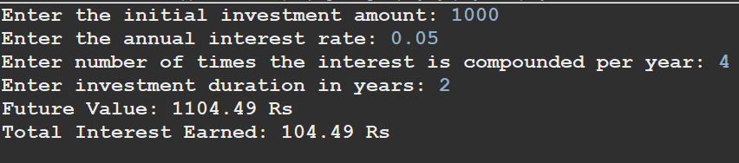

# BMI (Body Mass Index) Tracker

**BMITracker.java**

import java.util.Scanner;

public class BMITracker {

private double weight;

private double height;

private double bmiValue;

public void acceptRecord(Scanner sc){

System.out.print("Enter weight in kg: ");

this.weight = sc.nextDouble();

System.out.print("Enter height in meters: ");

this.height = sc.nextDouble();

}

public void printRecord(){

System.out.printf("BMI: %.2f\n", bmiValue);

}

public void calculateBMI(){

bmiValue = weight / (height * height);

}

public void classifyBMI(){

if(bmiValue<18.5)

System.out.println("Underweight");

else if(bmiValue>=18.5 && bmiValue<25)

System.out.println("Normal weight");

else if(bmiValue>=25 && bmiValue<30)

System.out.println("Overweight");

else

System.out.println("Obese");

}

}

**Tester.java**

import java.util.Scanner;

public class Tester {

public static void main(String[] args) {

Scanner sc = new Scanner(System.in);

BMITracker obj1 = new BMITracker();

obj1.acceptRecord(sc);

obj1.calculateBMI();

obj1.printRecord();

obj1.classifyBMI();

sc.close();

}

}

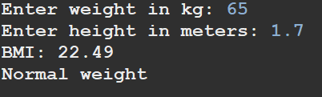

# Discount Calculation for Retail Sales

**DiscountCalculator.java**

package in.cdac.ques4;

import java.util.Scanner;

public class DiscountCalculator {

private double originalPrice;

private double discountRate ;

private double discountAmount;

private double finalPrice;

public void acceptRecord(Scanner sc){

System.out.print("Enter the original price: ");

this.originalPrice = sc.nextDouble();

System.out.print("Enter the discount precentage: ");

this.discountRate = sc.nextDouble();

}

public void calculateDiscount (){

discountAmount = originalPrice * (discountRate / 100);

finalPrice = originalPrice - discountAmount;

}

public void printRecord(){

System.out.printf("Discount amount: %.2f Rs\n", discountAmount);

System.out.printf("Final price: %.2f Rs", finalPrice);

}

}

**Tester.java**

package in.cdac.ques4;

import java.util.Scanner;

public class Tester {

public static void main(String[] args) {

Scanner sc = new Scanner(System.in);

DiscountCalculator obj1 = new DiscountCalculator ();

obj1.acceptRecord(sc);

obj1.calculateDiscount();

obj1.printRecord();

sc.close();

}

}

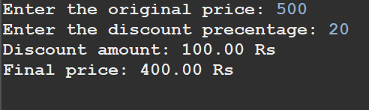

1. Toll Booth Revenue Management

**TollBoothRevenueManager.java**

package in.cdac.ques5;

import java.util.Scanner;

public class TollBoothRevenueManager {

private double tollRateCar;

private double tollRateTruck;

private double tollRateMotorcycle;

private int noOfCars;

private int noOfTrucks;

private int noOfMotorcycles;

private int totalNoOfVehicles;

private double totalRevenue;

public void acceptRecord(Scanner sc){

System.out.print("Enter the number of Cars: ");

this.noOfCars = sc.nextInt();

System.out.print("Enter the number of Trucks: ");

this.noOfTrucks = sc.nextInt();

System.out.print("Enter the number of Motorcycles: ");

this.noOfMotorcycles = sc.nextInt();

}

public void setTollRates(Scanner sc){

System.out.print("Set the toll rate for Car: ");

this.tollRateCar = sc.nextDouble();

System.out.print("Set the toll rate for Truck: ");

this.tollRateTruck = sc.nextDouble();

System.out.print("Set the toll rate for Motorcycle: ");

this.tollRateMotorcycle = sc.nextDouble();

}

public void calculateRevenue (){

totalNoOfVehicles = noOfCars + noOfTrucks + noOfMotorcycles;

totalRevenue = (tollRateCar * noOfCars) + (tollRateTruck * noOfTrucks) + (tollRateMotorcycle * noOfMotorcycles);

}

public void printRecord(){

System.out.println("Total number of vehicles: "+totalNoOfVehicles);

System.out.printf("Total Revenue collected: %.2f Rs", totalRevenue);

}

}

**Tester.java**

package in.cdac.ques5;

import java.util.Scanner;

public class Tester {

public static void main(String[] args) {

Scanner sc = new Scanner(System.in);

TollBoothRevenueManager obj1 = new TollBoothRevenueManager ();

obj1.acceptRecord(sc);

obj1.setTollRates(sc);

obj1.calculateRevenue();

obj1.printRecord();

sc.close();

}

}

